Flights-Pro

Windows 10 Installation Guide

# Project Overview:

This guide will walk a user through the process of retrieving the Flights-Pro project code and configuring it to run in a Windows 10 environment.

# Required Programs:

* PowerShell 5 (should already be installed as part of Windows 10)  
  <https://www.microsoft.com/en-us/download/details.aspx?id=54616>
* .Net Framework 4.5 or higher  
  <https://dotnet.microsoft.com/download>
* Java JDK  
  <https://www.oracle.com/java/technologies/javase-jdk16-downloads.html>
* GIT (Download the Windows executable)  
  <https://git-scm.com/downloads>
* Web browser of your choice

# Installation Steps:

## Step 1 – Program Installations

Download and install (or verify the installation of) all programs listed under the Required Programs section. Choose the default options during all install wizards. (Note – It shouldn’t matter either way, but is simpler to just go with defaults for the purpose of this guide.)

## Step 2 – Download Clojure

Open an elevated PowerShell window. Enter the following command:

iwr -useb download.clojure.org/install/win-install-1.10.3.967.ps1 | iex

This will download the Clojure tools. You will then be prompted with choosing an install location. (Note - For my setup, options 2 and 3 require admin privileges, hence the opening of an elevated PowerShell.)

If successful, your screen should look similar to what is shown below.

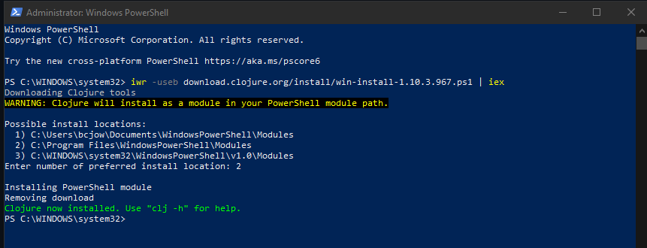

## Step 3 – Download Flights-Pro code

Create a folder to store the Flights-Pro code somewhere on your machine, and then navigate to that folder. Enter the following command:  
  
git clone https://github.com/rururu/flights-pro.git

This will retrieve the Flights-Pro code from the git repository. Your screen should look similar to what is shown below.

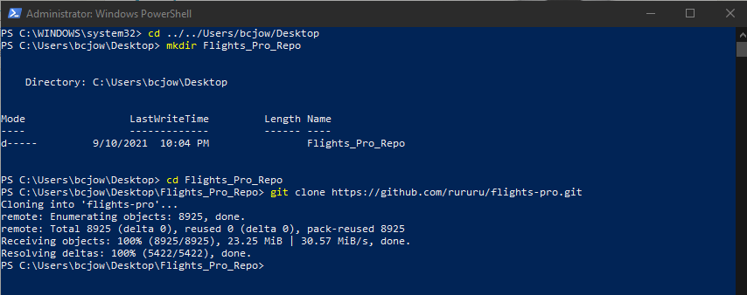

## Step 4 – Resolve Potential Errors

Navigate to the flights-pro folder, and enter the following command:

clj

You will most likely run into a couple of errors. If you don’t, skip to the next step.

The first error you will receive states:

The 'clj' command was found in the module 'ClojureTools', but the module could not be loaded. For more information, run 'Import-Module ClojureTools'.

If you try to run the import, you’ll likely receive a second error, which states:

Import-Module : File C:\Program Files\WindowsPowerShell\Modules\ClojureTools\ClojureTools.psm1 cannot be loaded because running scripts is disabled on this system.

To fix this error, you will need to run the following command and type Y for the prompt:

Set-ExecutionPolicy RemoteSigned

This reduces the security level on your machine and only allows PowerShell to run scripts signed by a trusted publisher. Now you can enter the import command:

Import-Module ClojureTools

Optional - It’s best to set the script execution policy back to default, which will prevent any scripts from running. (Note – You will have to change this execution policy each time you open/close PowerShell or you can leave the policy as RemoteSigned.) Run the following command and type Y for the prompt:

Set-ExecutionPolicy Restricted

Depending on your system and errors received, your screen should look similar to what is below.

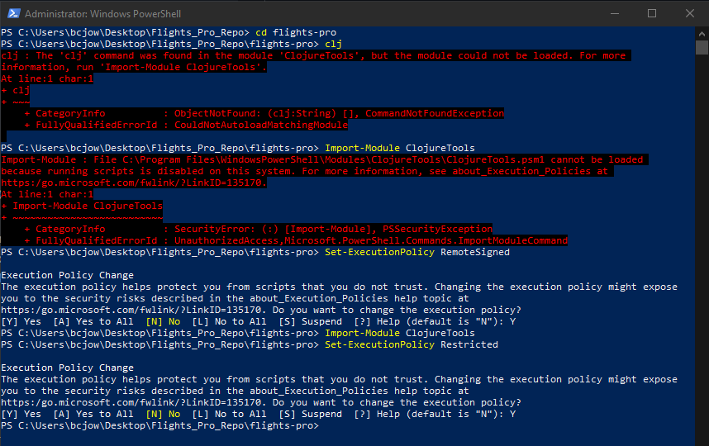

## Step 5 – Run Clojure

Enter the following command to start Clojure:

clj

The first time this command is run, it will download a bunch of files. You should then be presented with the user prompt. Enter the following:

(edu.stanford.smi.protege.Application/main (into-array String []))

The command above tells Clojure to execute Protégé. This comes prepackaged when you retrieved the Flights-Pro code. Protégé will open with a welcome dialog box. Your screen should look similar to what is shown below.

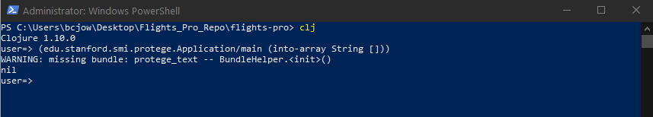

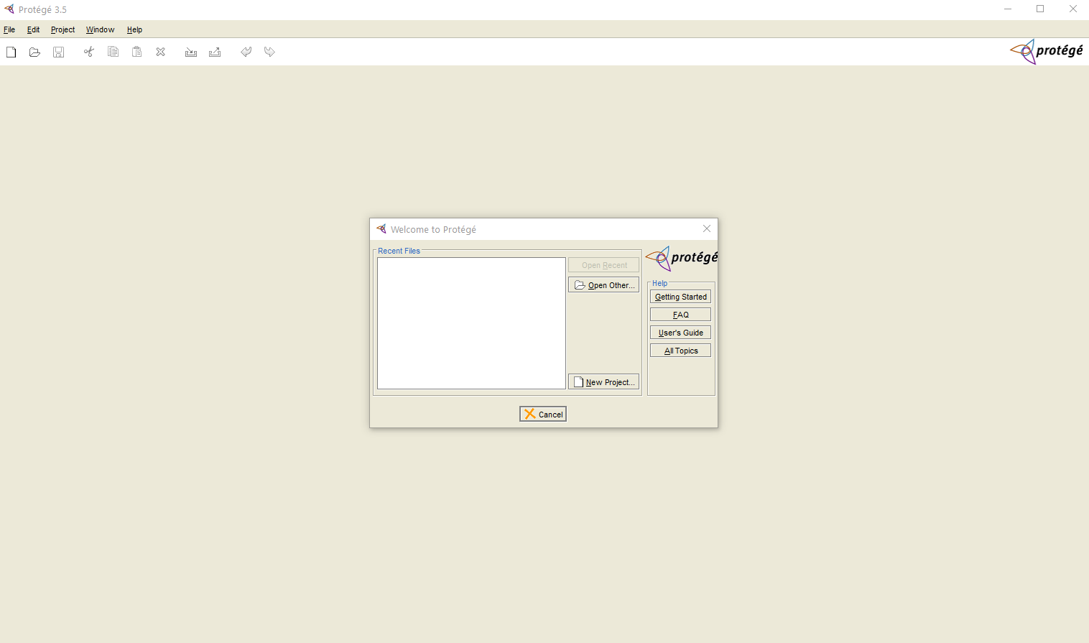

## Step 6 – Run Flights-Pro

Click the Open Other… button on the welcome dialog box in Protégé. Navigate to the FlightPro.pprj project file inside folder ./flights-pro/pro-projects and open it.

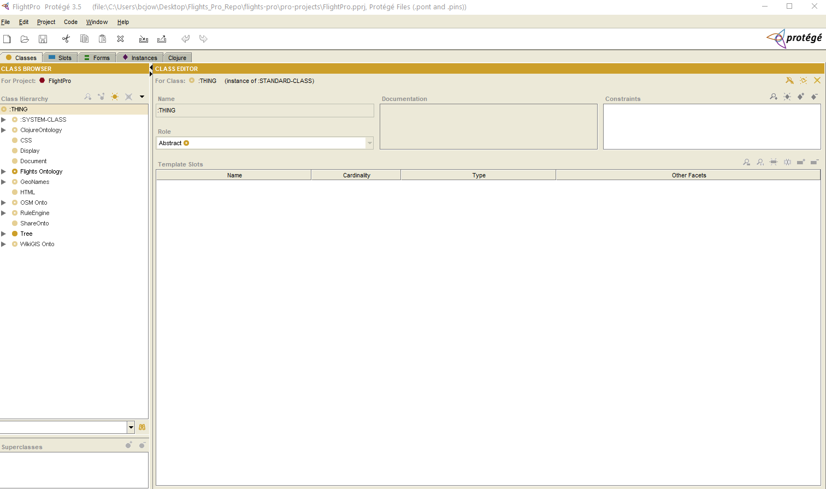

With the project open, go to Edit -> Clojure Work. This will start a handful of programs and servers necessary for Flights-Pro to run. Notice back in PowerShell, commands and information have been written to the screen.

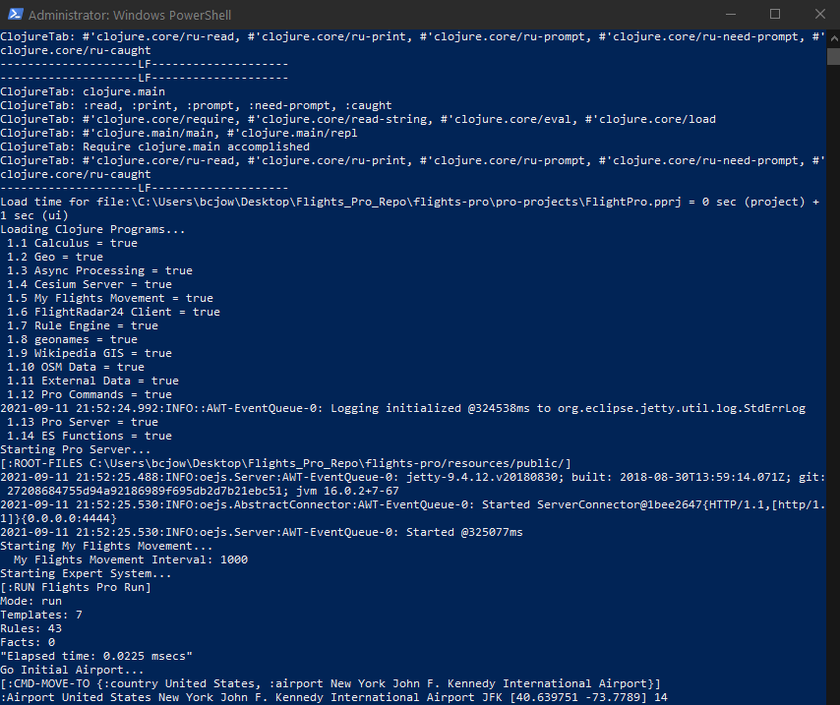

Open a browser with two tabs. Navigate to <http://localhost:4444/> (cockpit view) in the first tab, and <http://localhost:4444/chart> (chart view) in the second tab.

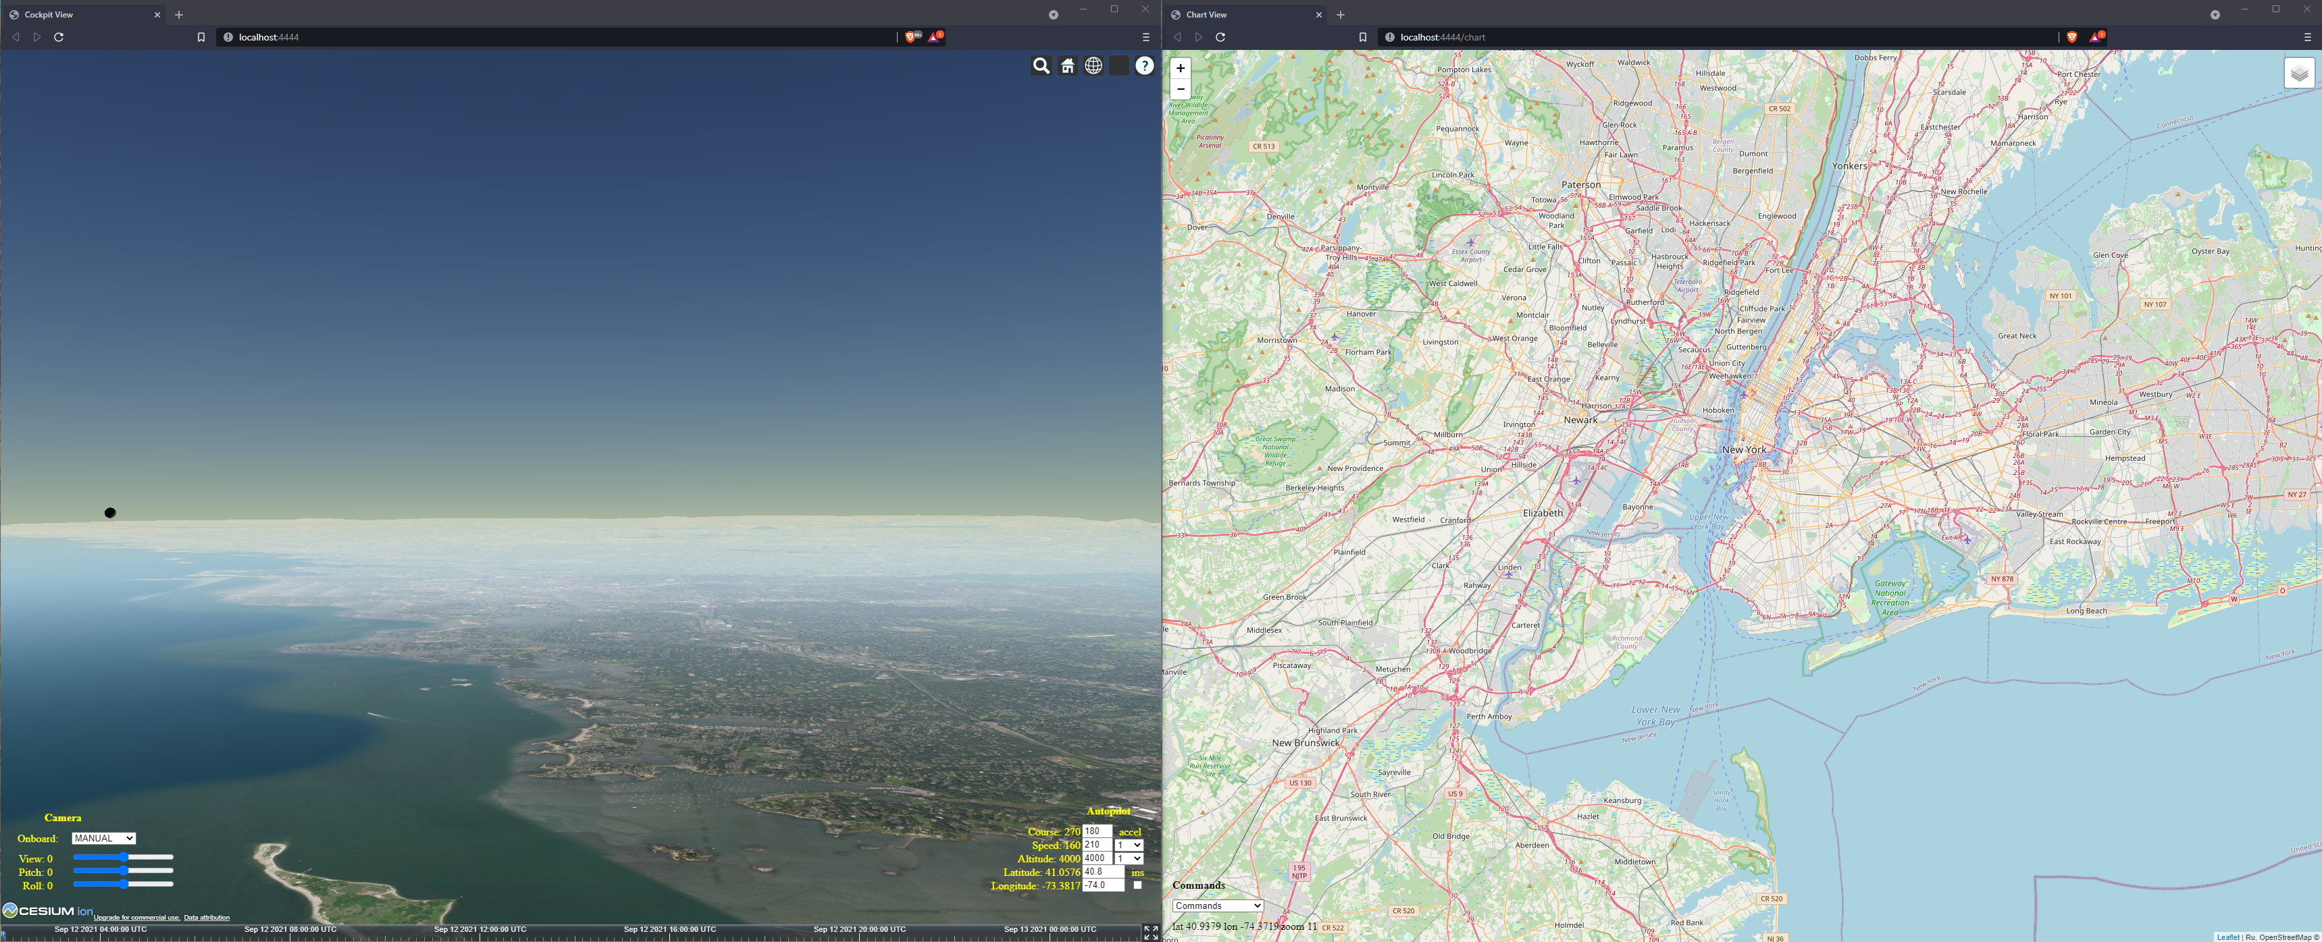

# References:

Flights-Pro git repository  
<https://github.com/rururu/flights-pro>